Electronic Document Recording Services
[County name] is electronically recording (eRecording) land records. Documents that originate on paper, such as loan closing documents, are scanned and placed into their proper recording order. When fully integrated, the electronic document recording process takes only seconds.
Advantages of eRecording with [County name]:
- Reduced labor, materials, postage, and courier costs
- Shortened time gap to recordation
- Fewer document errors and rejections
- Elimination of payment errors on county fees
- Increased security when sending and receiving documents
- Improved tracking and filing of documents
- Reduced consumption of fuel, electricity, and paper

How to get started
[County name] accepts documents from CSC eRecording at erecording.com. Please contact them to get started. A computer, scanner, and internet connection are all you need to begin eRecording today.
[Please feel free to use the official CSC logo on your website. Click here to access the file, then right click and choose “Save As” to download it.]
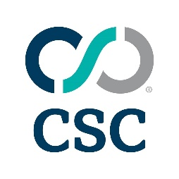

CSC contact information
eRecording support: 866-652-0111
erecording@cscglobal.com
erecording.com

